Report

Question number:19

|  |
| --- |
| NAME:MAYANK SINGLA |
| 19BCS4287 |
| CSE(MC) |

AIM: **Design system for a game that displays and increments score by 1 whenever a football hits a desired target out of 4 given targets.**

**COMPONENTS WHICH ARE USED:**

**1:Bread board**

**2:Arduino UNO**

**3:Wires**

**4:Display screen**

**5:switch**

**6:LED**

**7:Resistance**

**8:object where we hit the ball (4 TARGETS)**

**Diagram:**

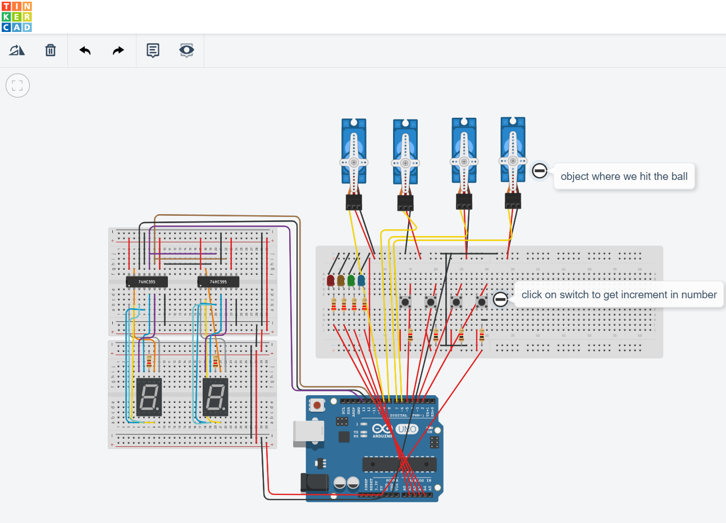

**Precautions:**

**1:Don't plug in an LED without a current limiting resistor.**

**2:Don't supply it with more then 9V unless you know what Thermal Resistance and Power Dissipation mean.**

**3:Don't plug it into unknown circuits.**

**4:Don’t attach arduino with computer when you will make circuit.**

**Learning outcomes:**

**When we hit the football on desired target out of 4 the displays will increment score by 1.**

**If you want to check video it is present on givenlink (**<https://github.com/Mayanksingla139/BEEE_CU_EVALUTION/blob/master/VID_20191021_214620.mp4>)

**THANKS**